**Custom Actions and Search Filters**

* Enhance your Salesforce experience with the power of custom actions and search filters! By leveraging these remarkable features, you can effortlessly tailor the QLE and configurator to perfectly align with your unique business requirements
* Let's deep dive into Custom Action and Search Filters -

**Custom Actions: Optimizing Your Sales Process**

* Salesforce CPQ offers a powerful array of custom actions, which are action-oriented buttons. Custom Actions can significantly enhance your sales workflow.
* These dynamic buttons can be seamlessly integrated into various sections such as the **QLE**, **configurator**, or **detail pages**, providing your sales representatives with flexibility and efficiency.

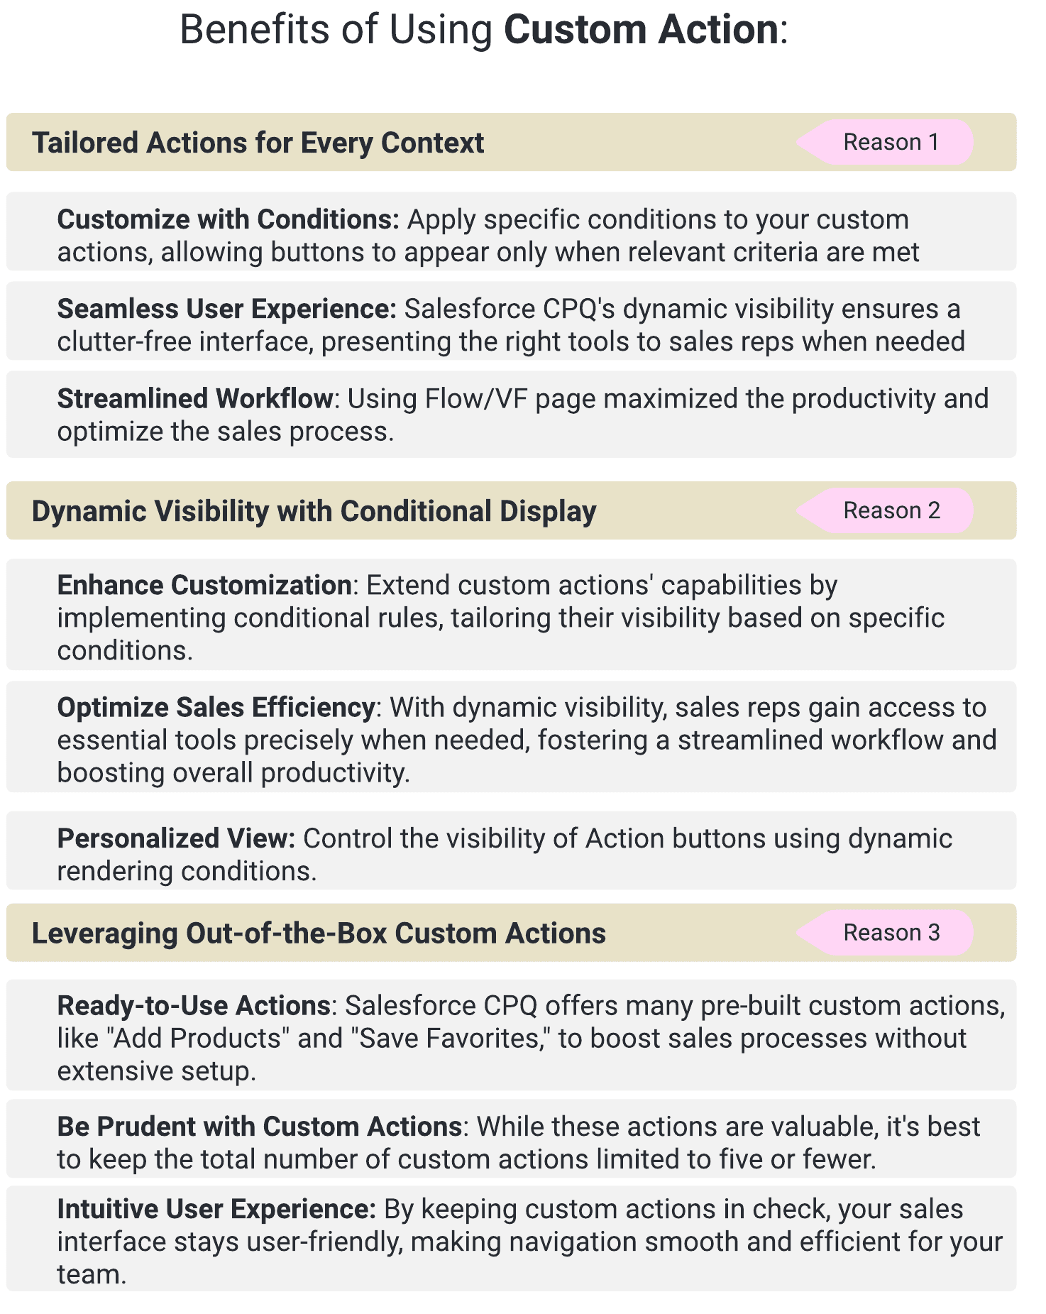

**Use Case:**Let's understand Custom action with the help of a use case-

Show a button called "Hardware Product" Once clicked it should show all products where Product Family is Hardware.

**Steps to Create Custom Action:**

Before we follow the steps let's understand some important fields -

* **Name**: The name of the custom action.
* **Display Order**: Specifies where the custom action is displayed.
* **Type**: Determines whether the custom action is a button, menu, or separator. In this example, we are creating a button for service products. 3 Options - Button, Menu, Separator
* **Parent Custom Action**: If you want to group a child's custom action under an existing custom action, then you need to select this.
* **URL Target**: If your custom action is a URL, then you can provide the link here. You can give the VF page and Flow link.
* **Page**: This is where your custom action will be displayed.
* **Location**: The place where the custom action appears on the chosen page.
* **Action**: Determines the result of selecting a custom action. In this example, let's select Add Products.
* **Label**: Display the name in the QLE for the end users. Create a label picklist field in the custom objects by navigating to Setup Object Manager Custom Action Fields & relationship Label Values New. Add the new picklist value. In this example, we are adding Service Product. Once the picklist value is added, you can select that in the Label field here.

Please setup the data as given in the screenshot-

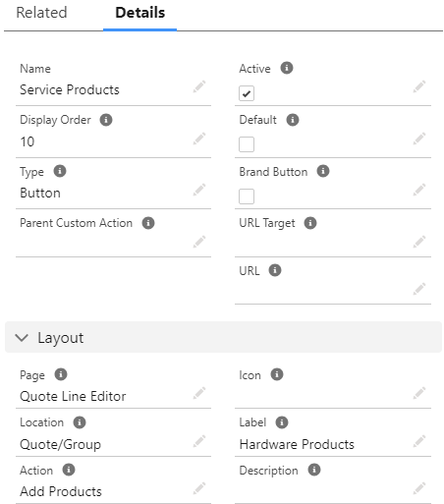

Add a new value in the Label field -Hardware Products and Save the record.

Now let's click on the related tab and under Search Filters click on the New button. Add the records with the following details -

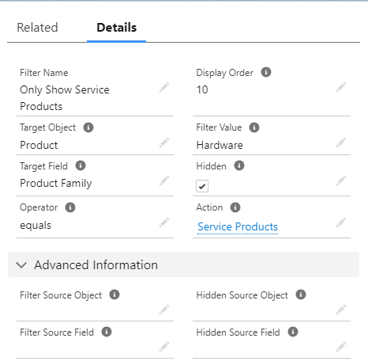

Save the records.

Let's See how it is showing -



The Hardware Service button is visible to All Users. If we want to restrict this to some profile or add any other condition we need to create a new record under **Custom Action Conditions**.

**Create a Search Filter:**

Search filters are used to filter products based on the search criteria. Search filters can be created from custom actions.

**Let's see the steps to create Search Filters:**

1. Go to the Custom Action tab
2. Select the Action that we have created in the above steps - Hardware Products
3. Click on the Related tab and under the Search Filter section, click on the New button and add the values as given in the screenshot-

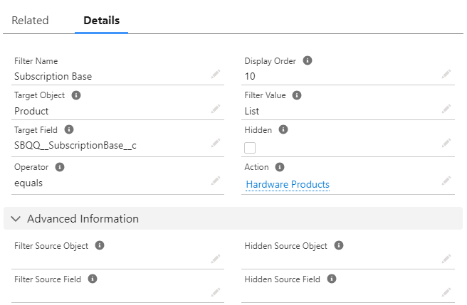

Here make sure we have not checked the Hidden field.

1. Click on save.

Now go to Quote and click on any quote. Click on Edit Lines and then click on the Hardware Product Button. Now you will notice, the filter icon is visible. Click on that icon and now you will see the Subscription Base option showing.

Let's check the demo -



Interview Questions-

1. There are two buttons – Hardware Products and Software Products, for *Hardware Support Profile*, I want to show *Hardware Product* button and for *Software Support Profile* I want to show *Software Product* button. How can we do that?  
    OR  
   How can you control the visibility and accessibility of custom actions in Salesforce CPQ?  
    OR  
   What is the use of Custom Action Condition in Custom Action record?
2. What is the use of Search Filter?
3. What is the use of Hidden checkbox on Search Filter?
4. What are type of custom action we can use in QLE page?